**Computer Engineering Department**



**Faculty of Engineering**

**Cairo University**

**Modeling & Simulation**

**Lab #2: SPICE Simulator (Part1)**

**Introduction:**

SPICE Circuit simulator is a well-known modern circuit simulator that uses direct methods to simulate analog circuits at the differential equation level. It takes an analog circuit schematic, simulates, calculates and plots the voltage at each node, and the current produced by each voltage source

**System Architecture:**

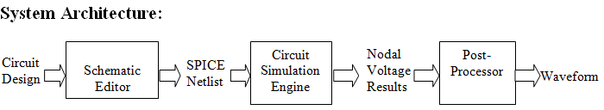

1. **Schematic Editor**

* Generate a Netlist file to be passed to the simulator engine.

Netlist Format:

------------------------------------------------------------------------------

Component_Type | Node1 | Node2 | Value | Initial_Value

------------------------------------------------------------------------------

* Component_Type stands for the type of the component. It can be one of the following:
* Voltage Source "Vsrc".
* Current Source "Isrc".
* Resistance "R".
* Node1 and Node2 stands for the nodes‟ numbers to which the component is connected to. (for uni-polar components as Vsrc, Node1 is the +ve port, Node2 is the –ve port)
* Value is the physical value of the component.
* Initial_Value is the initial current or voltage that is observed on the component at time=0.

1. **Circuit Simulation Engine**

* The simulation engine is responsible for performing all the numerical calculations necessary to compute the various circuit parameters (i.e. nodal voltages and voltage source currents).
* You can use the Modified Node Analysis algorithm with Backward Euler method. A short review on this algorithm will be presented during the lab.

1. **Post-Processor**

* The module is responsible for displaying the results of the simulator in both tabular form and waveform.

**Requirement:**

You're required to develop **Circuit Simulation Engine** using any general purpose programming language (C/C++/C# or Java). It takes netlist as an input and generates nodal voltage results as an output. Your simulator should be able to simulate circuits composed of: Resistor, Voltage Source and Current Source.

NOTE:

1. You could use python, (you are allowed to use libraries for matrix determinant, adjunct or inversion)
2. Matlab is not allowed
3. Grading Criteria

|  |  |
| --- | --- |
| **Parse File** | **1** |
| **Get n,m** | **1** |
| **Matrix G** | **2** |
| **Matrix B** | **1.5** |
| **Matrix C** | **0.5** |
| **Matrix D** | **0.5** |
| **Matrix i(1st part of Z)** | **1.5** |
| **Matrix v(2nd part of Z)** | **1.5** |
| **Solve equation** | **0.5** |
|  | **10** |

**Appendix 1: Matrix Operations**

You may need to remember some matrix operations.

1. **Matrix Transpose**

The transpose of a nxm matrix is the swapping of rows & columns to produce a mxn matrix

Aij = Aji

1. **Determinant of Matrix**

The determinant of a nxn matrix could be computed by:



Where Mi,j is the determinant of a subgroup of the larger matrix A, after deleting a row i & col j from A

1. **Adjunct of Matrix**

Adjunct of Matrix A is the transpose of cofactor Matrix C



Where each element of C is Mi,j the determinant of subgroup of the larger matrix A, after deleting a row i & col j from A



1. **Matrix Cross Multiplication (x)**

2 Matrices could be multiplied if matrix A is [n x m] & matrix B is [m x p], so the output matrix C will be [n x p], where

Cij = Summ(Aim * Bmj)

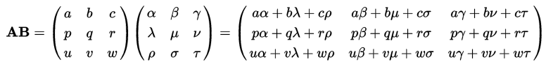

1. **Matrix Dot Multiplication (.)**

2 Matrices could be dot multiplied by multiplying each matrix element

Cij = Aij * Bij

1. **Matrix Inverse**

Matrix Inverse is calculated using the determinant & adjunct of the matrix

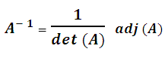

**Appendix 2: Coding Advices**

1. **Recursive Functions**

When writing your matrix class, remember that you will need to use recursion. For example: when coding determinant of A “Det_Mat(A,n)”,

Det_A = Det_A + ( (-1)^(i+j) * A[i,j] * Det_Mat(Sub_Mat(A,i,j),n-1) );

1. **Incremental Development**

After you finish implementing a function (as determinant), test your function using the results from any online calculator as;

<https://matrix.reshish.com/>

<http://onlinemschool.com/math/assistance/matrix/>